Міністерство освіти і науки України

Державний університет “Житомирська політехніка”

Кафедра інженерії програмного забезпечення

Група: ВТ-21-1[1]

Програмування мовою Python

Лабораторна робота № 3

«Розгалуження та цикли»

Виконав: Бабушко А. С.

Прийняв: Морозов Д. С.

***Мета роботи:*** ознайомитися зі рядками в мові Python, діями над ними.

***Хід роботи:***

***Завдання на лабораторну роботу:***



***Лістинг програми:***

*""" Lab 3. Python. Andrii Babushko. Repository: https://github.com/AndriiBabushko/Python """  
  
  
# task 1  
def* task_1_find_word_in_text(text, searching_letter):  
 count_searching_letters = 0  
 searching_letter = searching_letter.capitalize()  
 split_text = text.split(' ')  
 *for* i *in* range(0, len(split_text)):  
 split_text[i] = split_text[i].capitalize()  
 *if* split_text[i][0] == searching_letter:  
 count_searching_letters += 1  
  
 *return* count_searching_letters  
  
  
print('\nTASK 1!!!')  
task_1_some_text = 'lorem ipsum lorem Ipsum dolor Dit amet, Consectetur adipiscing elit.'  
print(f'Task 1 text: "{task_1_some_text}"')  
task_1_some_searching_letter = str(input('Enter searching letter: '))  
print(f'Count of searching letter({task_1_some_searching_letter}) = '  
 f'{task_1_find_word_in_text(task_1_some_text, task_1_some_searching_letter)}')

***Результат програми:***

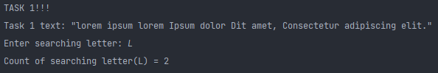



***Лістинг програми:***

*# task 2  
def* task_2_change_text(text):  
 new_text = text.replace(':', '%')  
 print(f'Text after changes: {new_text}')  
 *return* text.count(':')  
  
  
print('\nTASK 2!!!')  
task_2_some_text = ': % % :: %% dfd 1212dffd12121 % :'  
print(f'Task 2 text: "{task_2_some_text}"')  
print(f'Count changes from ":" to "%": {task_2_change_text(task_2_some_text)}')

***Результат програми:***

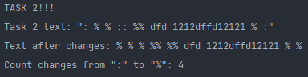



***Лістинг програми:***

*# task 3  
def* task_3_delete_dots(text):  
 new_text = text.replace('.', '')  
 print(f'Text after changes: {new_text}')  
 *return* text.count('.')  
  
  
print('\nTASK 3!!!')  
task_3_some_text = '. ; : ^% $ # @#$ *& )* .. ... . dfsd 123'  
print(f'Task 3 text: "{task_3_some_text}"')  
print(f'Count deleted "." : {task_3_delete_dots(task_3_some_text)}')

***Результат програми:***

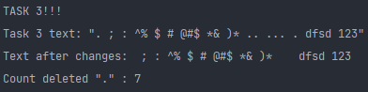



***Лістинг програми:***

*# task 4  
def* task_4_count_a_o(text):  
 new_text = text.replace('a', 'o')  
 print(f'Text after changes: {new_text}')  
 *return* [text.count('a'), len(new_text)]  
  
  
print('\nTASK 4!!!')  
task_4_some_text = 'a ddgdgdgdgd aa oaoaoaoao fdfgdaaafddfgooo o fgfdg oooaaa'  
print(f'Task 4 text: "{task_4_some_text}"')  
task_4_result = task_4_count_a_o(task_4_some_text)  
print(f'Count changes from "a" to "o": {task_4_result[0]}')  
print(f'String length: {task_4_result[1]}')

***Результат програми:***

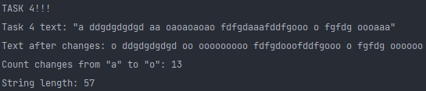



***Лістинг програми:***

*# task 5  
def* task_5_change_upper_lower(text):  
 new_text = text.lower()  
 *return* new_text  
  
  
print('\nTASK 5!!!')  
task_5_some_text = 'FDDFDF sdsdfsf FdHfHkLjNkKgGf FDFDsdsd dfdfDFFDFD'  
print(f'Text before changes: "{task_5_some_text}"')  
print(f'Text after changes: {task_5_change_upper_lower(task_5_some_text)}')

***Результат програми:***

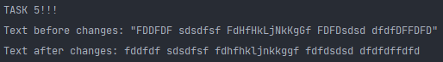



***Лістинг програми:***

*# task 6  
def* task_6_delete_o(text):  
 new_text = text.replace('o', '')  
 *return* [new_text, text.count('o')]  
  
  
print('\nTASK 6!!!')  
task_6_some_text = 'a ddgdgdgdgd aa oaoaoaoao fdfgdaaafddfgooo o fgfdg oooaaa'  
print(f'Text before changes: "{task_6_some_text}"')  
task_6_result = task_6_delete_o(task_6_some_text)  
print(f'Text after changes: {task_6_result[0]}')  
print(f'Count deleted "o" : {task_6_result[1]}')

***Результат програми:***

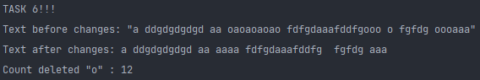



***Лістинг програми:***

*# task 7  
def* task_7_delete_o(text):  
 half_text = text[: int(len(text) / 2)]  
 new_text = half_text.replace('п', '*')  
 *return* new_text  
  
  
print('\nTASK 7!!!')  
task_7_some_text = 'п ввавввап ппп длодлдодлол ** авпвыпп * * * п п п'  
print(f'Text before changes: "{task_7_some_text}"')  
task_7_result = task_7_delete_o(task_7_some_text)  
print(f'Text after changes: {task_7_result}')

***Результат програми:***

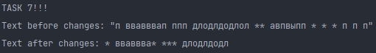



***Лістинг програми:***

*# task 8  
def* task_8_get_word_count_in_text(text, searched_word):  
 *return* text.count(searched_word)  
  
  
print('\nTASK 8!!!')  
task_8_some_text = 'apple banana ihor juice raccoon'  
print(f'Text for searching: "{task_8_some_text}"')  
task_8_searching_word = input('Enter searching word: ')  
task_8_result = task_8_get_word_count_in_text(task_8_some_text, task_8_searching_word)  
print(f'Count of word({task_8_searching_word}) in text: {task_8_result}')

***Результат програми:***

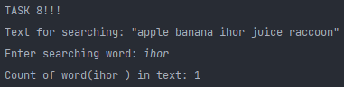



***Лістинг програми:***

*# task 9  
def* task_9_capitalize_first_word_letters(text):  
 split_text = text.split(' ')  
 *for* i *in* range(0, len(split_text)):  
 split_text[i] = split_text[i].capitalize()  
 *return* ' '.join(split_text)  
  
  
print('\nTASK 9!!!')  
task_9_some_text = 'Computer science, the study of computers and computing, including their theoretical and ' \  
 'algorithmic foundations, hardware and software, and their uses for processing information.'  
print(f'Text before changes: "{task_9_some_text}"')  
print(f'Text after changes: "{task_9_capitalize_first_word_letters(task_9_some_text)}"')

***Результат програми:***



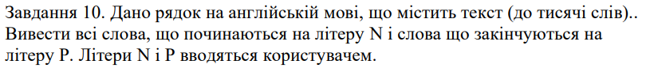

***Лістинг програми:***

*# task 10  
def* task_10_search_words_start_end_letters(text, start_letter, end_letter):  
 count_words = 0  
 upper_text = text.upper()  
 split_text = upper_text.split(' ')  
 start_letter = start_letter.upper()  
 end_letter = end_letter.upper()  
 *for* i *in* range(0, len(split_text), 1):  
 *if* split_text[i].startswith(start_letter) *and* split_text[i].endswith(end_letter):  
 count_words += 1  
 *else*:  
 *continue  
 return* count_words  
  
  
print('\nTASK 10!!!')  
task_10_some_text = 'nomputem nciencn, NhP NtudP of computers and computing, including their theoretical and ' \  
 'algorithmic Noundationp, hardware and MoftwarP, nnP their uses for NrocessinP information.'  
print(f'Text for task 10: "{task_10_some_text}"')  
task_10_start_letter = str(input('Enter start letter for searching: '))  
task_10_end_letter = str(input('Enter end letter for searching: '))  
task_10_result = task_10_search_words_start_end_letters(task_10_some_text, task_10_start_letter, task_10_end_letter)  
*if* task_10_result > 0:  
 print(f'Words that started with {task_10_start_letter} and end with {task_10_end_letter}: {task_10_result}')  
*else*:  
 print('No words found')

***Результат програми:***



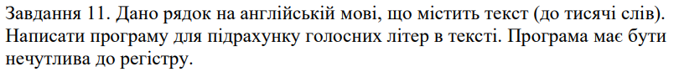

***Лістинг програми:***

*# task 11  
def* task_11_count_vowels(text):  
 count_vowels = 0  
 lower_text = text.lower()  
 vowels = {'a', 'e', 'i', 'o', 'u'}  
 *for* string *in* lower_text:  
 *if* string *in* vowels:  
 count_vowels += 1  
  
 *return* count_vowels  
  
  
print('\nTASK 11!!!')  
task_11_some_text = 'Computer science, the study of computers and computing, including their theoretical and ' \  
 'algorithmic foundations, hardware and software, and their uses for processing information.'  
print(f'Text for task 11: "{task_11_some_text}"')  
  
task_11_result = task_11_count_vowels(task_11_some_text)  
*if* task_11_result > 0:  
 print(f'Count of vowels: {task_11_result}')  
*else*:  
 print('No vowels found')

***Результат програми:***







***Лістинг програми:***

*# task 12  
def* task_12_count_consonant(text):  
 count_consonant = 0  
 lower_text = text.lower()  
 vowels = {'a', 'e', 'i', 'o', 'u'}  
 *for* string *in* lower_text:  
 *if* string *in* vowels:  
 *continue  
 else*:  
 count_consonant += 1  
  
 *return* count_consonant  
  
  
print('\nTASK 12!!!')  
task_12_some_text = 'Computer science, the study of computers and computing, including their theoretical and ' \  
 'algorithmic foundations, hardware and software, and their uses for processing information.'  
print(f'Text for task 12: "{task_12_some_text}"')  
  
task_12_result = task_12_count_consonant(task_12_some_text)  
*if* task_12_result > 0:  
 print(f'Count of consonants: {task_12_result}')  
*else*:  
 print('No consonants found')

***Результат програми:***



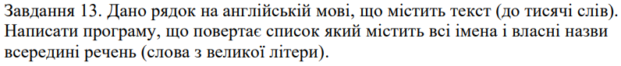

***Лістинг програми:***

*# task 13  
def* task_13_count_names(text):  
 count_names = 0  
 split_text_by_dot = text.split('. ')  
 *for* sentence *in* split_text_by_dot:  
 *for* index *in* range(0, len(sentence)):  
 *if* sentence[index].isupper():  
 count_names += 1  
 *else*:  
 *continue  
  
 return* count_names  
  
  
print('\nTASK 13!!!')  
task_13_some_text = 'When I enrolled in graduate school, things began to change. The registrar insisted that \n' \  
 'my email address and placard match the spelling of my name on my passport. For the first time' \  
 ' since \ngrade school, my name in the classroom was Roxani again. I couldn’t quite correct ' \  
 'my professors; \nRoxani was my name, after all, so I began to lead a bit of a double life. ' \  
 'I introduced myself \nas Roxanne — the only name I had ever called myself in English, and' \  
 ' a name most everyone could \npronounce. Roxani was reserved for Greece — for childhood,' \  
 ' parents, and a different self.'  
print(f'Text for task 13:\n"{task_13_some_text}"')  
  
task_13_result = task_13_count_names(task_13_some_text)  
*if* task_13_result > 0:  
 print(f'Count of names: {task_13_result}')  
*else*:  
 print('No names found')

***Результат програми:***

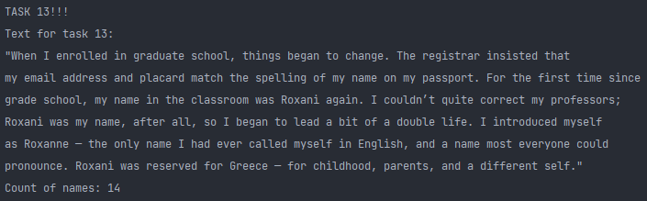

***Увесь лістинг програми:***

*""" Lab 3. Python. Andrii Babushko. Repository: https://github.com/AndriiBabushko/Python """  
  
  
# task 1  
def* task_1_find_word_in_text(text, searching_letter):  
 count_searching_letters = 0  
 searching_letter = searching_letter.capitalize()  
 split_text = text.split(' ')  
 *for* i *in* range(0, len(split_text)):  
 split_text[i] = split_text[i].capitalize()  
 *if* split_text[i][0] == searching_letter:  
 count_searching_letters += 1  
  
 *return* count_searching_letters  
  
  
print('\nTASK 1!!!')  
task_1_some_text = 'lorem ipsum lorem Ipsum dolor Dit amet, Consectetur adipiscing elit.'  
print(f'Task 1 text: "{task_1_some_text}"')  
task_1_some_searching_letter = str(input('Enter searching letter: '))  
print(f'Count of searching letter({task_1_some_searching_letter}) = '  
 f'{task_1_find_word_in_text(task_1_some_text, task_1_some_searching_letter)}')  
  
  
*# task 2  
def* task_2_change_text(text):  
 new_text = text.replace(':', '%')  
 print(f'Text after changes: {new_text}')  
 *return* text.count(':')  
  
  
print('\nTASK 2!!!')  
task_2_some_text = ': % % :: %% dfd 1212dffd12121 % :'  
print(f'Task 2 text: "{task_2_some_text}"')  
print(f'Count changes from ":" to "%": {task_2_change_text(task_2_some_text)}')  
  
  
*# task 3  
def* task_3_delete_dots(text):  
 new_text = text.replace('.', '')  
 print(f'Text after changes: {new_text}')  
 *return* text.count('.')  
  
  
print('\nTASK 3!!!')  
task_3_some_text = '. ; : ^% $ # @#$ *& )* .. ... . dfsd 123'  
print(f'Task 3 text: "{task_3_some_text}"')  
print(f'Count deleted "." : {task_3_delete_dots(task_3_some_text)}')  
  
  
*# task 4  
def* task_4_count_a_o(text):  
 new_text = text.replace('a', 'o')  
 print(f'Text after changes: {new_text}')  
 *return* [text.count('a'), len(new_text)]  
  
  
print('\nTASK 4!!!')  
task_4_some_text = 'a ddgdgdgdgd aa oaoaoaoao fdfgdaaafddfgooo o fgfdg oooaaa'  
print(f'Task 4 text: "{task_4_some_text}"')  
task_4_result = task_4_count_a_o(task_4_some_text)  
print(f'Count changes from "a" to "o": {task_4_result[0]}')  
print(f'String length: {task_4_result[1]}')  
  
  
*# task 5  
def* task_5_change_upper_lower(text):  
 new_text = text.lower()  
 *return* new_text  
  
  
print('\nTASK 5!!!')  
task_5_some_text = 'FDDFDF sdsdfsf FdHfHkLjNkKgGf FDFDsdsd dfdfDFFDFD'  
print(f'Text before changes: "{task_5_some_text}"')  
print(f'Text after changes: {task_5_change_upper_lower(task_5_some_text)}')  
  
  
*# task 6  
def* task_6_delete_o(text):  
 new_text = text.replace('o', '')  
 *return* [new_text, text.count('o')]  
  
  
print('\nTASK 6!!!')  
task_6_some_text = 'a ddgdgdgdgd aa oaoaoaoao fdfgdaaafddfgooo o fgfdg oooaaa'  
print(f'Text before changes: "{task_6_some_text}"')  
task_6_result = task_6_delete_o(task_6_some_text)  
print(f'Text after changes: {task_6_result[0]}')  
print(f'Count deleted "o" : {task_6_result[1]}')  
  
  
*# task 7  
def* task_7_delete_o(text):  
 half_text = text[: int(len(text) / 2)]  
 new_text = half_text.replace('п', '*')  
 *return* new_text  
  
  
print('\nTASK 7!!!')  
task_7_some_text = 'п ввавввап ппп длодлдодлол ** авпвыпп * * * п п п'  
print(f'Text before changes: "{task_7_some_text}"')  
task_7_result = task_7_delete_o(task_7_some_text)  
print(f'Text after changes: {task_7_result}')  
  
  
*# task 8  
def* task_8_get_word_count_in_text(text, searched_word):  
 *return* text.count(searched_word)  
  
  
print('\nTASK 8!!!')  
task_8_some_text = 'apple banana ihor juice raccoon'  
print(f'Text for searching: "{task_8_some_text}"')  
task_8_searching_word = input('Enter searching word: ')  
task_8_result = task_8_get_word_count_in_text(task_8_some_text, task_8_searching_word)  
print(f'Count of word({task_8_searching_word}) in text: {task_8_result}')  
  
  
*# task 9  
def* task_9_capitalize_first_word_letters(text):  
 split_text = text.split(' ')  
 *for* i *in* range(0, len(split_text)):  
 split_text[i] = split_text[i].capitalize()  
 *return* ' '.join(split_text)  
  
  
print('\nTASK 9!!!')  
task_9_some_text = 'Computer science, the study of computers and computing, including their theoretical and ' \  
 'algorithmic foundations, hardware and software, and their uses for processing information.'  
print(f'Text before changes: "{task_9_some_text}"')  
print(f'Text after changes: "{task_9_capitalize_first_word_letters(task_9_some_text)}"')  
  
  
*# task 10  
def* task_10_search_words_start_end_letters(text, start_letter, end_letter):  
 count_words = 0  
 upper_text = text.upper()  
 split_text = upper_text.split(' ')  
 start_letter = start_letter.upper()  
 end_letter = end_letter.upper()  
 *for* i *in* range(0, len(split_text), 1):  
 *if* split_text[i].startswith(start_letter) *and* split_text[i].endswith(end_letter):  
 count_words += 1  
 *else*:  
 *continue  
 return* count_words  
  
  
print('\nTASK 10!!!')  
task_10_some_text = 'nomputem nciencn, NhP NtudP of computers and computing, including their theoretical and ' \  
 'algorithmic Noundationp, hardware and MoftwarP, nnP their uses for NrocessinP information.'  
print(f'Text for task 10: "{task_10_some_text}"')  
task_10_start_letter = str(input('Enter start letter for searching: '))  
task_10_end_letter = str(input('Enter end letter for searching: '))  
task_10_result = task_10_search_words_start_end_letters(task_10_some_text, task_10_start_letter, task_10_end_letter)  
*if* task_10_result > 0:  
 print(f'Words that started with {task_10_start_letter} and end with {task_10_end_letter}: {task_10_result}')  
*else*:  
 print('No words found')  
  
  
*# task 11  
def* task_11_count_vowels(text):  
 count_vowels = 0  
 lower_text = text.lower()  
 vowels = {'a', 'e', 'i', 'o', 'u'}  
 *for* string *in* lower_text:  
 *if* string *in* vowels:  
 count_vowels += 1  
  
 *return* count_vowels  
  
  
print('\nTASK 11!!!')  
task_11_some_text = 'Computer science, the study of computers and computing, including their theoretical and ' \  
 'algorithmic foundations, hardware and software, and their uses for processing information.'  
print(f'Text for task 11: "{task_11_some_text}"')  
  
task_11_result = task_11_count_vowels(task_11_some_text)  
*if* task_11_result > 0:  
 print(f'Count of vowels: {task_11_result}')  
*else*:  
 print('No vowels found')  
  
  
*# task 12  
def* task_12_count_consonant(text):  
 count_consonant = 0  
 lower_text = text.lower()  
 vowels = {'a', 'e', 'i', 'o', 'u'}  
 *for* string *in* lower_text:  
 *if* string *in* vowels:  
 *continue  
 else*:  
 count_consonant += 1  
  
 *return* count_consonant  
  
  
print('\nTASK 12!!!')  
task_12_some_text = 'Computer science, the study of computers and computing, including their theoretical and ' \  
 'algorithmic foundations, hardware and software, and their uses for processing information.'  
print(f'Text for task 12: "{task_12_some_text}"')  
  
task_12_result = task_12_count_consonant(task_12_some_text)  
*if* task_12_result > 0:  
 print(f'Count of consonants: {task_12_result}')  
*else*:  
 print('No consonants found')  
  
  
*# task 13  
def* task_13_count_names(text):  
 count_names = 0  
 split_text_by_dot = text.split('. ')  
 *for* sentence *in* split_text_by_dot:  
 *for* index *in* range(0, len(sentence)):  
 *if* sentence[index].isupper():  
 count_names += 1  
 *else*:  
 *continue  
  
 return* count_names  
  
  
print('\nTASK 13!!!')  
task_13_some_text = 'When I enrolled in graduate school, things began to change. The registrar insisted that \n' \  
 'my email address and placard match the spelling of my name on my passport. For the first time' \  
 ' since \ngrade school, my name in the classroom was Roxani again. I couldn’t quite correct ' \  
 'my professors; \nRoxani was my name, after all, so I began to lead a bit of a double life. ' \  
 'I introduced myself \nas Roxanne — the only name I had ever called myself in English, and' \  
 ' a name most everyone could \npronounce. Roxani was reserved for Greece — for childhood,' \  
 ' parents, and a different self.'  
print(f'Text for task 13:\n"{task_13_some_text}"')  
  
task_13_result = task_13_count_names(task_13_some_text)  
*if* task_13_result > 0:  
 print(f'Count of names: {task_13_result}')  
*else*:  
 print('No names found')

***Висновок:*** під час виконання лабораторної роботи було отримано навички роботи з рядками на мові Python з використанням допоміжних функцій та методів для роботи з цими рядками.